Why Water?
Leslie Lowes and Tom Nolan
Adapted from presentations at an earlier workshop by Dr. Rich Terrile and Dr. Geoff Briggs

"Water � it's everywhere", or that's what we perceive here on Earth. To us, it's a staple of life But what are the basic facts about water and its presence throughout the rest of the universe and our Solar System?
The chemical symbol for water is H2O, indicating that it is made of 2 hydrogen atoms and 1 oxygen atom. Hydrogen is the number one most abundant element in the Solar System, and oxygen is the third most abundant element. Oxygen is the second most abundant of all the reactive elements. H2O is an "asymmetric" molecule � it has a particular "V" shape with the oxygen atom in the middle and the hydrogen atom at each end of the "V". This imbalance of charge causes water to be a polar molecule and a "universal solvent", that is, many things dissolve in water.
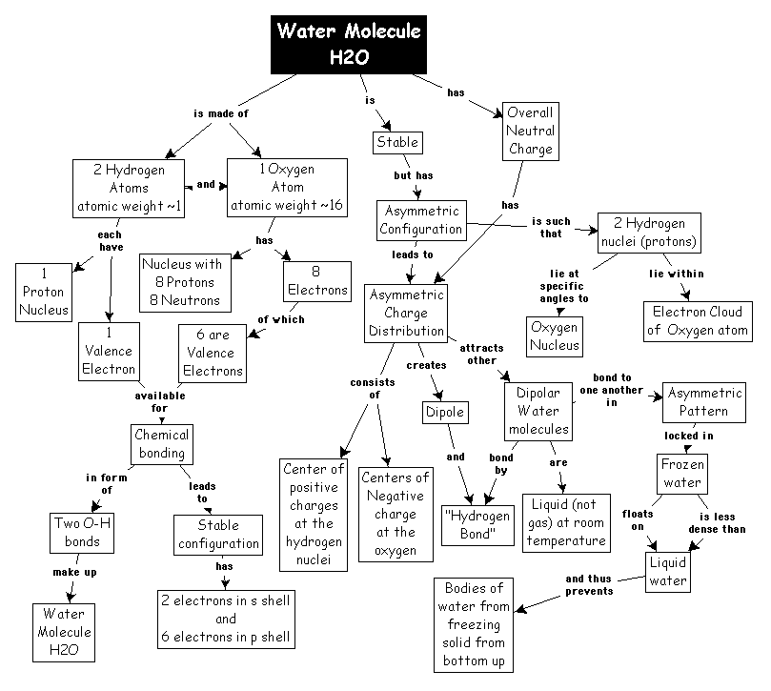
Attachment 1. The Chemistry of Water: Concept Map
Water stays liquid over a wide variety of temperatures and pressures.
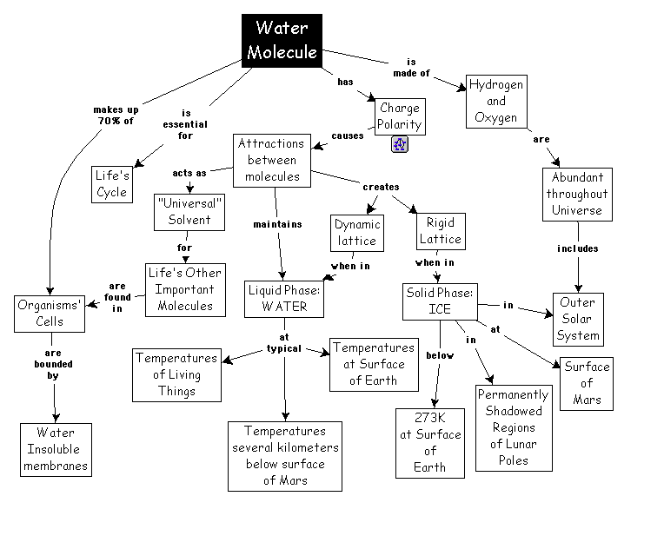
Attachment 2. Facts About Water: Concept Map
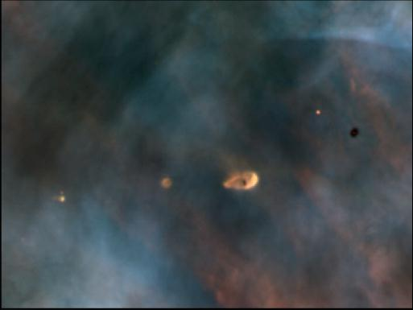
Figure 1. HST picture of Orion Nebula and "clouds", which are forming Solar Systems, called "proplyds"
Water signatures are found in interstellar space, in our Solar System, in the atmospheres of the outer planets and on the surfaces of their moons, and on Earth where it exists in all three forms � solid, liquid, and gas. Earth is unique in our Solar System because we have the "Goldilocks" effect; it's "not too hot, not too cold, but just right" for liquid water to exist on its surface.
Figure 2. The Earth as seen from the Galileo spacecraft
http://campus.coexploration.org/~caucus/LIB/nasa_main_hall/wsslowes/GLLearth.gif
THE EARTH.
Water and its distribution on Earth has been the topic of discussion for eons, the object of wars and treaties in all regions of the world, and the determiner of the world's population distribution more than any other factor. The cradles of our civilizations all began, and flourished, near water. Science fiction author Sir Arthur C. Clarke said that we misnamed our planet "Earth"; it obviously should be named "Ocean". He makes a good point, but it is doubtful that we will change the name on our mailbox after all these years!
Here are some amazing facts about water on Earth (compiled by the USGS):
Largest Ocean � Pacific Ocean with 64 MILLION! Square Miles
Deepest point in the Ocean � Mariana Trench (Pacific Ocean) 36,000 feet down
River that Carries the Most Water � Amazon River (South America) pours 4 million cubic feet into the Atlantic EVERY SECOND!
Longest River � Nile River (Africa) 4,145 miles
Muddiest River � Yellow River (China) where 2 BILLION tons of soil are washed down yearly
Highest Waterfall � Angel Falls (Venezuela) with a total drop of 3,212 feet
Deepest and Oldest Lake � Lake Baikal (Siberia) deepest part 6,365 feet and it is 25 million years old
We are challenged with either too much or too little water in all regions of the Earth during one season or another, making successful management of this resource extremely critical. The recent El Nino and the current La Nina conditions have altered weather and climate patterns worldwide, with some of the effects being beneficial and others devastating.
The health of the hydrologic cycle depends on our appreciation of the delicate balance and interactions of water on land, air, and ocean, and this is critical to our continued role as stewards of this planet. The more we learn about Earth's energy and carbon cycles, the more we understand water's vital role in balancing and distributing both. Monitoring Earth's water conditions helps scientists predict climate variations and protect lives and assets. The use of satellites has greatly increased our abilities to do so and NASA and NOAA are at the forefront of global climate monitoring, prediction and change.
Life as we know it cannot exist without liquid water, so it is sometimes called the "broth of life". We've found liquid water in every form of life on Earth, and conversely, every place we've found liquid water on Earth, we've also found life. Water is an essential component of life and all of its known forms depend on liquid water for its very existence.
It may surprise you to learn about the other environments in our Solar System that also have liquid water! The fact that there are other places where water has been found is particularly exciting because of possibility of life on other planets in our Solar System, in our own backyard.
Figure 3. The planets in our Solar System, to scale relative to each other
http://campus.coexploration.org/~caucus/LIB/nasa_main_hall/wsslowes/ssscale.jpg
THE SOLAR SYSTEM.
Basically, the planets in our Solar System are different depending on a principle that we call a "snow line". The four Inner Planets are basically little moats of dust around our star, the sun, and our Earth is one of these. The outer Solar System has most of the mass, and with the exception of Pluto, the Outer Planets are made mostly of gas and are hundreds of times the volume of the Earth. Why are outer planets so large?
When the Solar System formed about 4.5 billion years ago, there was initially a cloud of gas around the sun. The cloud was hot in center, and cold to the outside (like standing in front of a campfire). The Inner Planets formed in the hot environment, and so they are made of things that condense at very high temperature, like rocks, ceramics, etc. As you go out in this "nebula", you reach the "snow line" - the point where ice can condense. And once it starts to condense, it accumulates much faster, and the planets get larger and also accumulate gas, which makes them even larger. There is actually an abundance of ice and water in the outer part of the Solar System.
There is also plenty of water present in the inner Solar System as well � Earth has the equivalent of a layer of water 2 miles thick over the entire surface. What is the source of this water?
Figure 4. Comet Hall-Bopp (with meteoroid streak in picture)
http://campus.coexploration.org/~caucus/LIB/nasa_main_hall/wsslowes/hpyoung.jpg
Comets are mainly made of water, and may have "brought our oceans to Earth" in a manner of speaking. In the initial period of accumulation of material in the planets, comets, which were formed way out in the cold, extreme edges of the Solar System, were strewn around by the gravity of the larger planets, and may have delivered a large amount of water to the inner part of Solar System.
But Earth may not be the only place in our Solar System that has an ocean of water!
Figure 5. True (left) and false color images of Jupiter's moon Europa
http://campus.coexploration.org/~caucus/LIB/nasa_main_hall/wsslowes/Europaglobal.jpg
JUPITER'S MOON EUROPA.
The last time an ocean was discovered was in 1513 by Vasco Nunez de Balboa, when he reached the Pacific Ocean. Now, almost 500 years later, we discover that Europa, one of Jupiter's moons, most likely has had an ocean of water underneath its surface of frozen water ice at some point in recent geologic history. The Galileo spacecraft, currently orbiting the planet Jupiter, has given us the best images of Europa yet. How deep might that ocean be? Scientists believe that the ocean could have a depth of as much as about 100 kilometers (or 62 miles). If this is indeed true, then Europa may have twice as much water on it than on all of the Earth.
Why do we think there could be an ocean there? Many features on Europa's surface appear to have resulted from the disruption of material floating up from underneath, or to have slid apart while buoyed on top of other material. Why do we think the ocean has existed recently? Europa's surface is very youthful; that is, it has been changing a lot compared to many other bodies. We know this is true because of its remarkable lack of craters. Consider, for example, Earth's moon, which is covered with craters. Then consider Earth, which has very few. Considering the craters came from bombardment by comets and meteoroids, why would it be that our moon has so many and the Earth so few? The answer is because the Earth's surface is constantly being changed, by volcanoes, by the collision and drifting apart of the Earth's plates, and by erosion from wind and water. Changes to the surface erase evidence of craters relatively quickly on a geologic time scale.
So when we see so few craters on Europa's surface, we conclude that it, too, has a surface that is changing and active � it is geologically young.
But just how youthful is Europa's surface? How recently have the last changes been made? Is the ocean still there today, which scientists believe has existed in the not-to-distant past? These are the intriguing questions that scientists are trying to answer. Based on the scientific interest generated by the images and discoveries from the current Galileo mission, a new mission, called the Europa Orbiter, is planned for launch in 2003. It is scheduled to arrive at Jupiter and start studying Europa three years later, and will attempt to determine if the ocean is still present and if so, how thick the ice above it is and the depth of the ocean itself.
And where there's water, energy, and the right mix of organic material (which may come from the bombardment of Europa by comets), there could be life, and that possibility, which can only be investigated by missions in the future, also draws us to Europa. Since water is the "broth of life", which has been cooking on Europa since it was formed about 4.5 billion years ago, there is a potentially an exciting experiment happening on Europa.
Even science fiction authors are intrigued. For example, Arthur C. Clarke's sequels to 2001: A Space Odyssey, 2010: Odyssey Two, 2061: Odyssey Three, and 3001: The Final Odyssey, all deal with Europa and its possibility of life.
As on Earth, the water that is present on other bodies could be utilized by humans if they have access to it.
Figure 6. Image of the Moon's "backside", from the Galileo spacecraft
http://campus.coexploration.org/~caucus/LIB/nasa_main_hall/wsslowes/GLLmoon.gif
THE EARTH'S MOON.
The Lunar Prospector spacecraft discovered water at the polar regions of the Moon in 1998. Scientists decided that it was important to investigate the possibility of water there, since comets that collided with the moon may have brought water to this otherwise quite dry environment. The water could still remain at the poles in the form of ice mixed in with the soil to a depth of a few meters, because it is so cold and shielded from much sunlight there. Water on the Moon could be useful as a key resource in the on-going exploration of the rest of the Solar System. Since humans are resource-intensive compared to unmanned robotic spacecraft, the availability of water on the moon could make the human exploration of the rest of the Solar System a stronger possibility. The Apollo missions did not explore the polar regions of the moon.
But recently, the moon has been explored robotically by the Clementine spacecraft from the Department of Defense, which showed some hints of water at the poles of the moon. The presence of water later was confirmed by the Lunar Prospector mission, which was launched in January 1998 and mapped the chemical composition of the entirety of the moon's surface. Lunar Prospector recently ended by an intentional impact with the moon in July 1999.
Water from the Moon could be used for life support purposes, but could be used most promisingly as a fuel for rockets, by splitting the water apart into hydrogen and oxygen. In the distant future, the poles of the Moon could be used as a fuel station for exploration beyond the moon, most likely to the more distant points in our Solar System. Thus the results from the Lunar Prospector mission serve as a stepping stone to the future.
Figure 7. Mars global image, dominated by the "Vallis Marinaris" canyon
http://campus.coexploration.org/~caucus/LIB/nasa_main_hall/wsslowes/marsglobal.gif
THE PLANET MARS.
Mars is the closest neighboring planet to the Earth. We have clearly seen the signature of water on Mars. It had liquid water on it at sometime in the past, and this is why we are excited about that planet. In fact, we became excited about it first when Percival Lowell, an astronomer, misinterpreted the names used for features on Mars by another scientist, Scaparelli. When observing the linear features on the surface of Mars with telescopes, Scaparelli referred to them as "canalae", which means "channels". Lowell mistranslated canalae to mean canals, and speculated that they were put in place by an intelligent civilization. He thought these canals were used to bring water from the cold polar regions of Mars to the relatively hotter equatorial areas to irrigate farms! We now know, of course, that this theory is incorrect, but this started the public's imagination thinking about Mars and the possibility of life in the Solar System.
The story of the exploration of Mars is still unfolding, and is intimately tied in with water, where it exists, and whether or not it life may exist there. Most recently, in 1997, the Pathfinder mission landed on Mars with its Sojourner rover. The rover was intentionally landed in what was believed to be an area where deposits from several ancient rivers came together, allowing a study of rocks that are now in one place that probably originally came from a different sources. On December 3,1999 the next lander will touch down in the area of Mars' south pole to study, among other things, the effects of water there. Any water that is on Mars still today is expected to be beneath the surface.
The exploration of Europa, Mars, and our Moon are all realities happening today, making for an exciting future of potential explorations and discoveries, based on the existence of water.

